

**School of Applied Technical Sciences**

**Sensors & Actutaors Lab (ME3620)**

**Section 3**

**Exp #8 – Displacement & proximity sensors B**

**Instructor: Faysal Matar**

**Group B**

|  |  |
| --- | --- |
| **Name** | **ID** |
| Ali Al-Tememi | 20202102034 |
| Loai Tumeh | 20201102037 |

**Test equipments:**

1. The LVDT trainer kit (ST2303)
2. NI ELVIS II
3. The kit of the sensors (held on the NI ELVIS II).
4. Ruller or Measuring rope.

**Test specimens:**

1. Sensor Modules.
2. Test Objects:

* Ferromagnetic Materials: Objects with magnetic properties for testing the magnetic field sensor.
* Reflective Surfaces: Surfaces with different reflectivity for testing the optical position sensor.

1. ST2303 calibration.
2. NI ELVIS Kit Components:

* NI ELVIS II Workstation: The primary workstation that integrates with various sensor modules and provides a platform for data acquisition and analysis.
* Prototyping Board: A breadboard or similar prototyping area for assembling sensor circuits and connecting them to the NI ELVIS system.
* Data Acquisition Modules: DAQ modules compatible with NI ELVIS for capturing sensor data and interfacing with a computer for analysis.
* LabVIEW Software: Software for designing and running virtual instruments, capturing data, and performing analysis.

**Procedure:**

**(LVDT):**

1. We connected the ST2303 to power and then press the on button.
2. We connected the digital multimeter to the kit (the red wire on the output and the black wire to the GND)
3. We turned the multimeter on and put the milli Voltage channel to show the output voltage from the sensor.
4. We put the micrometer initial value to 0 and we wrote down the value of the output voltage and the core displacement (from the display on the kit).
5. We repeated the sequence for the remaining readings.
6. We calculated the sensitivity for all the readings in the table.

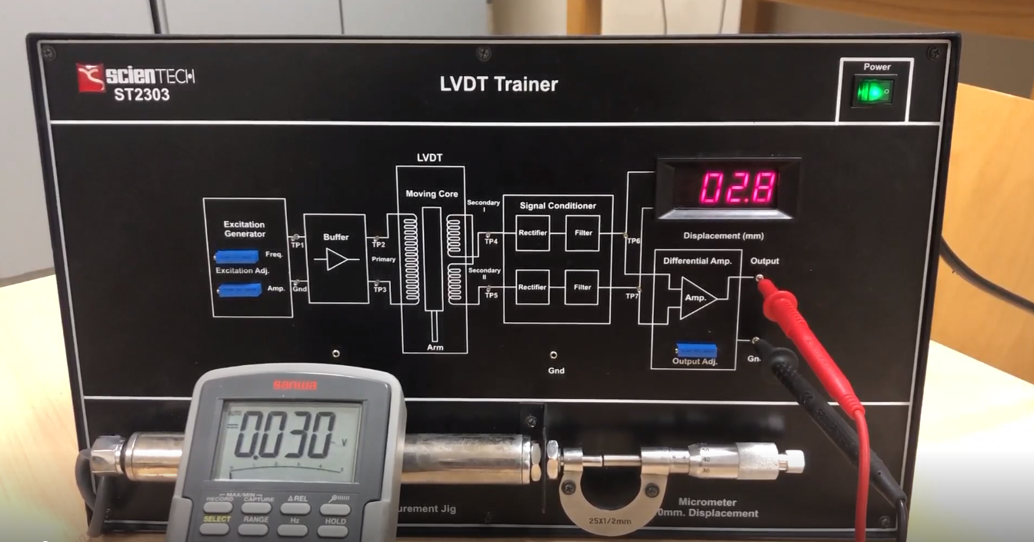

Figure 1.1: The initialization of ST2303 kit

**(magnetic field sensor):**

1. We connected the NI ELVIS II to the power and turned it on by pressing the button.
2. We ensured that J8 is set to Magnetic Field.
3. We opened the (QNET_MECHKIT_Magnetic_Field.vi) and we ran it.
4. We gently turned the knob of the magnetic field sensor clockwise until it is at its limit. Then, we rotated the knob slightly counterclockwise so the 0 mark on the knob faces up. Then we entered this in the Target Range (inch) array.
5. We entered the voltage measured from the magnetic field position sensor for the reference 0-inch position in the Sensor Measurement (V) array.
6. We turned the knob counter-clockwise one rotation to move the target further from the sensor. The target moves 1-inch for every 20 turns. We entered the position the target has moved from the reference in the Target Range (inch) array.
7. We recorded the measured sensor voltage in the Sensor Measurement (V) array.
8. We took samples for the entire range of the target (i.e. until the knob cannot be rotated CCW anymore).
9. We filled up the table.
10. We entered Gain and Damping exponential function parameters to correctly measure the distance of the target.

Figure 1.2: Collecting magnetic field data

Figure 1.3: Calibrating the magnetic field transducer.

**(Optical Position Sensor):**

1. We ensured J7 is set to Optical Position.
2. We opened the (QNET_MECHKIT_Optical.vi). We made sure the correct Device was chosen. Then we ran it.
3. We Gently turned the knob of the optical position sensor clockwise until the flat metal surface gently rests on top of the tube. Then, we rotated the knob slightly counterclockwise so the 0 mark on the knob faces up. At this point, the reflective target is very close to the optical sensor and will be the reference 0-inch position.
4. We Entered the voltage measured by the optical position sensor, when the target is 0 inches away, in the Sensor Measurement (V) array.
5. We Turned the knob counterclockwise one rotation to move the target further from the sensor. The target moves 1-inch for every 20 turns. We Entered the position the target has moved from the reference in the Target Range (inch) array.
6. We Recorded the measured sensor voltage in the Sensor Measurement (V) array.
7. We took samples for the entire range of the target (i.e. until the knob cannot be rotated counter-clockwise any- more). We remarked that the optical position sensor is exponential. As data is being entered, the exponential parameters are generated, and the fitted curve is automatically plotted.
8. We Entered the measured sensor data and capture the Sensor Readings response.
9. We Selected the Calibrate Sensor tab, entered values for the Gain and Damping exponential function parameters, to correctly measure the distance of the target, e.g. when target is 0.10 inches away then display should read 0.10 inches.
10. We Clicked on Stop button to stop the VI.

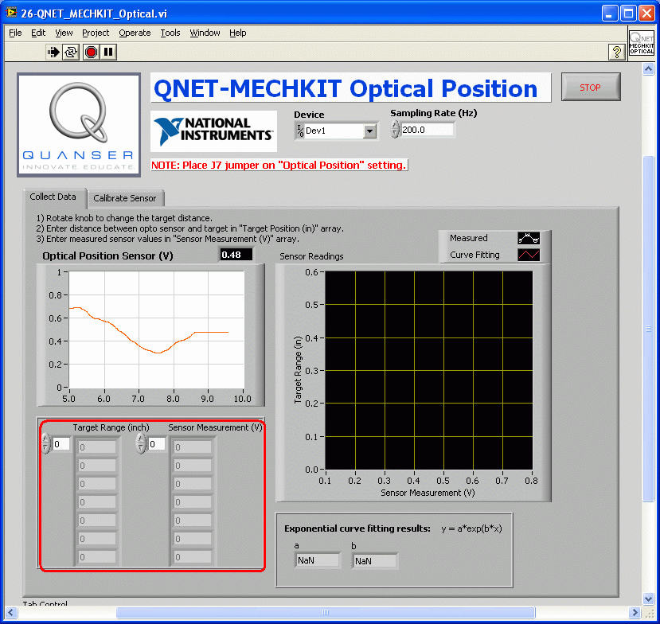

Figure 1.4: Collecting optical position data.

Figure 1.5: Calibrating the optical position sensor.

**(Sonar):**

1. We ensured J9 is set to Sonar.
2. We opened (the QNET_MECHKIT_Sonar.vi). We made sure the correct Device is chosen. Then we ran it.
3. We got a target, such as a sturdy piece of cardboard, that is at least 10 × 10unitcm2 with a reflective color like white or yellow.
4. We Began with the target close to the sonar sensor and slowly move it upward.
5. Once the lower end of its range of operation is found, we entered the distance between the target and the sonar sensor in the Target Range (cm) array.
6. We Entered the corresponding measured voltage from the sonar sensor in the Sensor Measurement (V) array.
7. We Repeated for different target positions. The sonar sensor is linear, and the slope and intercept are generated, and the fitted curve is automatically plotted.
8. We entered our collected target distances and voltages in Table.
9. We Selected the Calibrate Sensor tab and enter Gain (in cm/V) and Oﬀset (in cm) coefficients to correctly measure the distance of the target based on your measurements from the previous laboratory experiment. Make sure the coefficients are correct, e.g. when the target is 10.0 inches away then the Sonar (inch) display should read 10.0 inches.
10. We Clicked on Stop button to stop the VI.

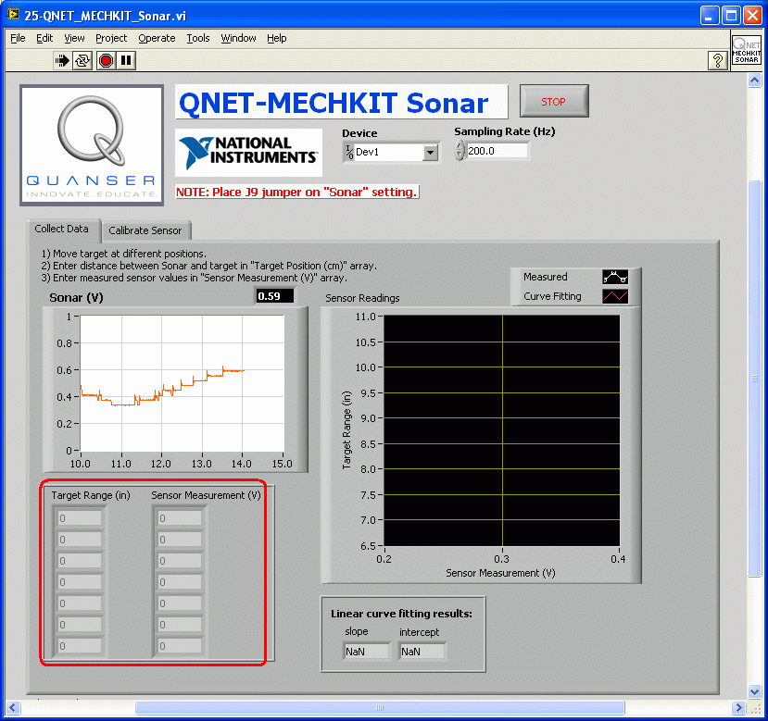

Figure 1.6: Collecting sonar data.

Figure 1.7: Calibrating the sonar sensor.

**Data and analysis:**

**(LVDT):**

Table 1.1: LVDT readings

|  |  |  |  |  |  |  |  |  |  |  |  |
| --- | --- | --- | --- | --- | --- | --- | --- | --- | --- | --- | --- |
| **Micrometer Reading**  **(mm)** | **0** | **2** | **4** | **6** | **8** | **10** | **12** | **14** | **16** | **18** | **20** |
| **Output voltage**  **(mV)** | 70 | 50.5 | 30.84 | 11.3 | -8.81 | -28.6 | -48.6 | -68.1 | -87.2 | -105.9 | -123.1 |
| **Core displacement**  **(mm)** | 6.2 | 4.3 | 2.4 | 0.4 | -1.5 | -3.5 | -5.5 | -7.4 | -9.3 | -11.1 | -12.9 |
| **Sensitivity S calculated**  **(mV/mm)** | / | 10.26 | 10.35 | 9.77 | 10.58 | 9.85 | 10 | 10.26 | 10.05 | 9.88 | 9.55 |

**Sample of calculations for S:**

S2 = (50.5 – 70) / (4.3 – 6.2) = 10.26 mV/mm

Savg = sum(si)/10 = 10.082

Figure 1.8: Vout and Core displacement relation.

As we can see it is linear relationship.

**(Magnetic Field Sensor):**

Table 1.2: Magnetic Field sensor readings

|  |  |  |
| --- | --- | --- |
| **Parameter** | **Value** | **Unit** |
| Sensor Measurement @ 0 in | 1.42 | V |
| Sensor Measurement @ 0.025 in | 1.7 | V |
| Sensor Measurement @ 0.050 in | 1.94 | V |
| Sensor Measurement @ 0.075 in | 2.06 | V |
| Sensor Measurement @ 0.100 in | 2.17 | V |
| Sensor Measurement @ 0.125 in | 2.23 | V |
| Sensor Measurement @ 0.150 in | 2.28 | V |
| Sensor Measurement @ 0.175 in | 2.31 | V |
| Sensor Measurement @ 0.200 in | 2.34 | V |

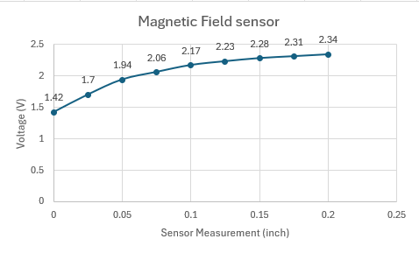

Figure 1.9: Relationship between Sensor Measurement and Vout.

As we can see It is exponential relationship.

**(Optical Position Sensor):**

Table 1.3: Optical field sensor readings

|  |  |  |
| --- | --- | --- |
| **Parameter** | **Value** | **Unit** |
| Sensor Measurement @ 0 in | 1.56 | V |
| Sensor Measurement @ 0.025 in | 1.07 | V |
| Sensor Measurement @ 0.050 in | 0.85 | V |
| Sensor Measurement @ 0.075 in | 0.6 | V |
| Sensor Measurement @ 0.100 in | 0.5 | V |
| Sensor Measurement @ 0.125 in | 0.36 | V |
| Sensor Measurement @ 0.150 in | 0.31 | V |
| Sensor Measurement @ 0.175 in | 0.24 | V |
| Sensor Measurement @ 0.200 in | 0.21 | V |
| Sensor Measurement @ 0.225 in | 0.17 | V |
| Sensor Measurement @ 0.250 in | 0.15 | V |
| Sensor Measurement @ 0.280 in | 0.13 | V |

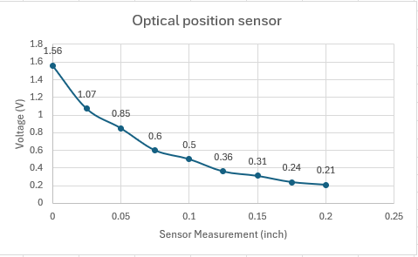

Figure 1.10: Relationship between Sensor Measurement and Vout.

As we can see the relationship is negative exponential or decreases exponentially.

**(SONAR):**

Table 1.4: SONAR sensor readings

|  |  |  |
| --- | --- | --- |
| **Parameter** | **Value** | **Unit** |
| Sensor Measurement @ 6 inch | 0.24 | V |
| Sensor Measurement @ 12 inch | 0.35 | V |
| Sensor Measurement @ 18 inch | 0.54 | V |
| Sensor Measurement @ 24 inch | 0.68 | V |
| Sensor Measurement @ 30 inch | 0.89 | V |

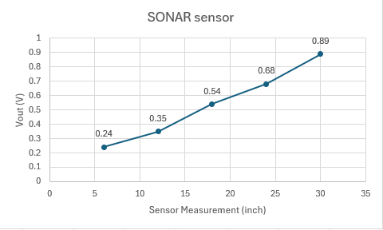

Figure 1.11: Relationship between Sensor Measurement and Vout.

As we can see the relationship is approximately linear.

**Discussion:**

**(LVDT):**

* The sensitivity value indicates how responsive the LVDT sensor is to changes in displacement. A higher sensitivity means the sensor produces a larger output signal change for a given displacement, which typically results in higher measurement precision.
* The sensitivity of a Linear Variable Differential Transformer (LVDT) sensor refers to the relationship between the output signal and the displacement of the core. Specifically, it quantifies how much the output signal changes per unit of displacement.
* Given that the average sensitivity of the LVDT sensor in the experiment is 10.082, it means that for every unit of displacement, the output signal changes by 10.082 units. However, the exact meaning of "units" for both displacement and output depends on the specific calibration and configuration of your LVDT sensor setup.
* A linear relationship in an LVDT experiment means the output voltage is a straightforward, proportional indicator of the core displacement, making the sensor easy to use and the results easy to interpret.
* Some sources of Errors in LVDT Experiment and Mitigation Methods:

1. Mechanical Misalignment:

* Error Contribution: Causes non-linearities and inaccuracies.
* Mitigation: Ensure precise alignment using quality fixtures and tools.

1. Electrical Noise and Interference:

* Error Contribution: Introduces unwanted signals.
* Mitigation: Use shielded cables, proper grounding, and filtering techniques. Place equipment away from noise sources.

1. Hysteresis Effects:

* Error Contribution: Causes different outputs depending on movement direction.
* Mitigation: Use low-hysteresis materials and consistent measurement techniques.

1. Calibration Errors:

* Error Contribution: Leads to inaccurate displacement conversions.
* Mitigation: Regularly calibrate with precise standards and follow a strict procedure.
* Real life applications:

1. Industrial Automation: LVDT sensors are used in automated manufacturing processes to measure the position of components such as machine parts, robotic arms, and hydraulic cylinders. They ensure precise control and alignment of machinery.
2. Aerospace and Defense: LVDTs are used in aircraft and missile systems for position feedback in control surfaces, landing gear, and throttle position. They provide critical data for flight control systems.
3. Civil Engineering: LVDT sensors are used in structural health monitoring of buildings, bridges, and dams. They measure structural deformations and displacements to ensure safety and integrity.
4. Medical Devices: LVDTs are used in medical equipment such as MRI machines, CT scanners, and robotic surgery systems. They provide accurate position feedback for precise control and imaging.
5. Automotive Industry: LVDT sensors are used in vehicle suspension systems, engine testing, and automotive testing equipment. They provide accurate displacement measurements for performance evaluation and testing.
6. Power Generation: LVDT sensors are used in hydroelectric and nuclear power plants to monitor the position of valves, turbines, and other components. They ensure efficient operation and safety.
7. Research and Development: LVDT sensors are used in laboratories and research facilities for material testing, vibration analysis, and motion control. They provide precise measurements for experimental setups.

**(MAGNETIC FIELD SENSOR):**

* An exponential relationship in a magnetic field sensor means that the output voltage grows (or decays) exponentially with displacement, resulting in a non-linear response. This type of response requires more careful calibration and interpretation, especially for large displacement measurements, due to the rapid changes in output voltage.
* Some sources of Errors in Magnetic field sensor Experiment and Mitigation Methods:

1. External Magnetic Fields:

Magnetic fields from nearby electronic devices, motors, or magnetic materials can interfere with the sensor's measurements, leading to inaccuracies. These fields can be strong and unpredictable.

Reduction Method: Use shielding materials around the sensor or relocate the sensor away from sources of external magnetic fields. Calibrate the sensor in the environment where it will be used to account for any residual interference.

1. Noise and Interference:

Electrical noise and interference from other sources can affect the sensor's output signal, leading to errors in measurement.

Reduction Method: Use shielding and filtering techniques to reduce noise and interference. Ensure proper grounding and isolation of the sensor and associated electronics.

1. Signal Processing Errors:

Errors in the signal processing algorithms or data acquisition system can lead to inaccuracies in the final measurement.

Reduction Method: Use reliable and well-tested signal processing algorithms. Ensure the data acquisition system is properly calibrated and functioning correctly.

* Real life applications:

1. Industrial Automation: Magnetic field sensors are used in industrial automation systems for position sensing, speed detection, and proximity sensing. They are used in conveyor systems, robotics, and assembly lines.
2. Automotive Industry: In vehicles, magnetic field sensors are used in speedometers, anti-lock braking systems (ABS), and gear position sensors. They are also used in electric vehicles for motor control and battery management.
3. Consumer Electronics: Magnetic field sensors are used in smartphones and tablets for compass applications, which determine the device's orientation relative to the Earth's magnetic field. They are also used in laptops for lid detection and in gaming consoles for motion sensing.
4. Security Systems: Magnetic field sensors are used in security systems for door and window sensors, as well as in motion detectors. They can detect the presence or movement of magnetic objects.
5. Medical Devices: In medical applications, magnetic field sensors are used in magnetic resonance imaging (MRI) machines for creating detailed images of the body's internal structures. They are also used in blood flow meters and in prosthetic devices for position sensing.
6. Navigation Systems: Magnetic field sensors are used in navigation systems for marine, aviation, and land-based applications. They help determine direction and heading, especially in environments where GPS signals are weak or unavailable.
7. Environmental Monitoring: Magnetic field sensors are used in geophysical surveying, earthquake detection, and monitoring of magnetic anomalies in the Earth's crust. They are also used in environmental monitoring stations to measure changes in the Earth's magnetic field.

**(Optical position):**

* This type of relationship (negative exponential) is often observed in systems where there is an inverse proportionality between two variables, and the rate of change decreases as the sensor measurement increases. In the case of an optical position sensor, it suggests that the output voltage decreases rapidly at first as the measurement increases, but the rate of decrease slows down as the measurement continues to increase.
* Sources of Errors in Optical Position Sensors:

1. Ambient Light Interference: Ambient light can interfere with the sensor's ability to detect the position accurately, especially in environments with varying light conditions.
2. Surface Reflectivity: The reflectivity of the surface being measured can affect the sensor's ability to detect the position, leading to errors in the measured position.
3. Sensor Alignment: Improper alignment of the sensor with the target can lead to errors in the measured position, especially if there is angular misalignment.
4. Signal Noise: Electrical noise in the sensor's output signal can lead to errors in the measured position, especially in environments with high electromagnetic interference.
5. Temperature Variations: Changes in temperature can affect the sensor's performance, leading to errors in the measured position.

* Contribution to Total Obtained Error:

These sources of errors can contribute to the total obtained error in the measured position by introducing inaccuracies in the sensor's output signal. Each error source can lead to a different magnitude of error, depending on the specific conditions of the measurement.

* Methods of Eliminating/Reducing Effects:

1. Ambient Light Shielding: Shielding the sensor from ambient light using enclosures or shields can reduce the effects of ambient light interference.
2. Surface Preparation: Using surfaces with consistent and known reflectivity can reduce errors caused by surface reflectivity variations.
3. Calibration and Alignment: Calibrating the sensor and ensuring proper alignment with the target can reduce errors caused by misalignment.
4. Signal Filtering: Using signal filtering techniques to reduce noise in the sensor's output signal can reduce errors caused by signal noise.
5. Temperature Compensation: Using temperature compensation techniques to account for temperature variations can reduce errors caused by temperature variations.
6. Improved Sensor Design: Using sensors with improved design features, such as higher resolution and sensitivity, can reduce errors in the measured position.
7. Environmental Control: Controlling the environment, such as maintaining stable light conditions and temperature, can reduce errors caused by environmental factors.

* Real life applications:

1. Robotics: Optical position sensors are used in robotics for precise control of robotic arms, grippers, and other moving parts. They provide feedback for positioning and motion control.
2. Industrial Automation: In manufacturing and industrial automation, optical position sensors are used in conveyor systems, assembly lines, and automated machinery for precise positioning and alignment of components.
3. Printers and Plotters: Optical position sensors are used in printers and plotters to detect the position of the print head or plotting pen. This allows for accurate printing or plotting of images or text.
4. Medical Devices: Optical position sensors are used in medical devices such as infusion pumps, robotic surgery systems, and diagnostic equipment for precise positioning and control.
5. Aerospace and Defense: In aerospace and defense applications, optical position sensors are used in aircraft controls, missile systems, and unmanned aerial vehicles (UAVs) for accurate positioning and navigation.
6. Automotive Industry: Optical position sensors are used in automotive applications for position sensing in throttle position sensors, pedal position sensors, and other control systems.
7. Consumer Electronics: Optical position sensors are used in consumer electronics such as cameras, smartphones, and gaming consoles for position sensing and gesture recognition.
8. Security Systems: Optical position sensors are used in security systems for motion detection, object tracking, and surveillance applications.

**(SONAR):**

* When we say that the relationship between the sensor measurement and the output voltage of a sonar sensor is approximately linear, it means that there is a linear correlation between the distance of an object from the sensor and the voltage value produced by the sensor.
* In simpler terms, as the distance between the sensor and an object change, the output voltage of the sensor changes proportionally. For example, if the distance doubles, the output voltage doubles as well. This linear relationship is beneficial because it makes it easier to interpret the sensor's output and calibrate it for distance measurements.
* Here are some common sources of error and ways to reduce or eliminate their effects:

1. Temperature Variations:

* Error Contribution: Changes in temperature can affect the speed of sound in air, leading to inaccuracies in distance measurement.
* Reduction Methods: Use temperature-compensated sensors or calibrate the sensor in the same temperature range as the application. Maintain a stable temperature environment if possible.

1. Object Shape and Material:

* Error Contribution: Irregularly shaped or absorbent materials can reflect sound waves unpredictably, leading to measurement errors.
* Reduction Methods: Use sensors with narrow beam angles to minimize reflections from nearby objects. Calibrate the sensor for specific object types if possible.

1. Calibration Errors:

* Error Contribution: Improper calibration or drift over time can lead to inaccurate distance measurements.
* Reduction Methods: Calibrate the sensor regularly using known distance references. Use calibration algorithms to correct for any drift or non-linearity in the sensor's response.

1. Signal Processing Delays:

* Error Contribution: Delays in signal processing can lead to inaccuracies in time-of-flight calculations.
* Reduction Methods: Use efficient signal processing algorithms and minimize processing delays. Ensure the system has sufficient computational resources for real-time processing
* Real life applications:

1. Underwater Navigation: SONAR is widely used in underwater vehicles, submarines, and ships for navigation and obstacle avoidance.
2. Fish Finding: In fishing, SONAR is used to locate schools of fish and determine their depth, helping fishermen increase their catch efficiency.
3. Marine Research: SONAR is used in marine research to study oceanography, marine biology, and geological formations on the ocean floor.
4. Depth Measurement: SONAR is used to measure the depth of bodies of water for purposes such as dredging, construction, and environmental monitoring.
5. Underwater Imaging: SONAR imaging techniques like side-scan SONAR are used to create detailed images of the seabed for geological surveys and archaeological studies.
6. Subsea Infrastructure Inspection: SONAR is used to inspect underwater structures like pipelines, cables, and offshore platforms for damage or integrity issues.
7. Search and Rescue Operations: SONAR is used in search and rescue missions to locate objects or individuals underwater, such as lost aircraft or drowning victims.
8. Military Applications: SONAR is used in naval applications for detecting submarines, underwater mines, and other threats.
9. Autonomous Underwater Vehicles (AUVs): SONAR is used in AUVs for autonomous navigation, mapping, and environmental monitoring.
10. Port Security: SONAR is used for underwater surveillance in ports to detect unauthorized underwater activities or threats.

**Conclusion:**

In this experiment, we explored the performance characteristics of four different sensors: the Linear Variable Differential Transformer (LVDT), SONAR, optical position, and magnetic field sensors. The scope of the experiment included understanding the operational principles, calibrating the sensors, and evaluating their performance.

**Scope of the Experiment:**

1. Study the working principles and calibration methods of LVDT, SONAR, optical position, and magnetic field sensors.
2. Evaluate the sensitivity of LVDT sensor.
3. Compare the performance characteristics of the sensors in similar experimental setups.
4. Assess the suitability of each sensor type for different applications requiring displacement and proximity measurements.

**Main Results:**

1. The LVDT sensor demonstrated high accuracy and linearity in measuring linear displacement.
2. The SONAR sensor showed reliable performance in measuring distances, with the ability to detect objects of various shapes and sizes.
3. The optical position sensor exhibited good sensitivity to position.
4. The magnetic field sensor provided consistent measurements in detecting magnetic fields, with a wide range of applications in proximity sensing.

**Outcomes:**

1. The experiment highlighted the importance of sensor selection based on application requirements, considering factors such as accuracy, environmental robustness, and ease of calibration.
2. The results showed that each sensor type has its strengths and limitations, suggesting that a combination of sensors might be beneficial for certain applications to overcome individual limitations.

In conclusion, this experiment provided a comprehensive understanding of the operational principles and performance characteristics of LVDT, SONAR, optical position, and magnetic field sensors. The results underscored the importance of sensor selection and calibration for accurate and reliable measurement of displacement and proximity in a wide range of applications.

**References:**

1. <https://www.te.com/en/products/sensors/position-sensors/resources/lvdt-tutorial.html#:~:text=LVDT%20is%20an%20acronym%20for,into%20a%20corresponding%20electrical%20signal>.
2. <https://en.wikipedia.org/wiki/Linear_variable_differential_transformer>
3. <https://www.geeksforgeeks.org/lvdt/>
4. <https://www.te.com/en/products/sensors/optical-sensors.html?te_bu=Sen&te_type=srch&te_campaign=ggl_glo_sen-ggl-global-srch-optical-sensors_sma-2335_3&elqCampaignId=163657&gad_source=1&gclid=CjwKCAjwupGyBhBBEiwA0UcqaF5HnBvdL3wlrwABKXPeVCqG4mWoUvOlkckTmU3PPqKkbZ56qZIslhoC7yYQAvD_BwE&tab=pgp-story>
5. <https://www.directindustry.com/industrial-manufacturer/optical-position-sensor-93945.html>
6. <https://www.globalspec.com/learnmore/sensors_transducers_detectors/linear_position_sensing/optical_triangulation_position_sensors>
7. <https://en.wikipedia.org/wiki/MEMS_magnetic_field_sensor>
8. <https://www.vernier.com/manuals/mg-bta/>
9. <https://en.wikipedia.org/wiki/Sonar>
10. <https://maxbotix.com/blogs/blog/how-ultrasonic-sensors-work>
11. <https://www.google.co.uk/>